# Apress LightSwitch 2012 (by Tim Leung) – Chapter 17

Chapter 17 focuses on authorization and access control. Engineers and managers can access the HelpDesk application. However, managers can access more parts of the application, compared to engineers.

This sample includes 5 permissions:

* CanEditEngineers
* CanChangeIssueDescription
* CanViewReport
* CanViewAllIssues
* CanBypassValidation

You can refer to the chapter to find out the relationship between roles, permissions, and users.

To run this example, follow the instructions below to mimic logging in as an engineer, and logging in as a manager.

## Logging in as an Engineer

To mimic logging in as an engineer, open the properties window of your application, uncheck all of the permissions, and run the application.

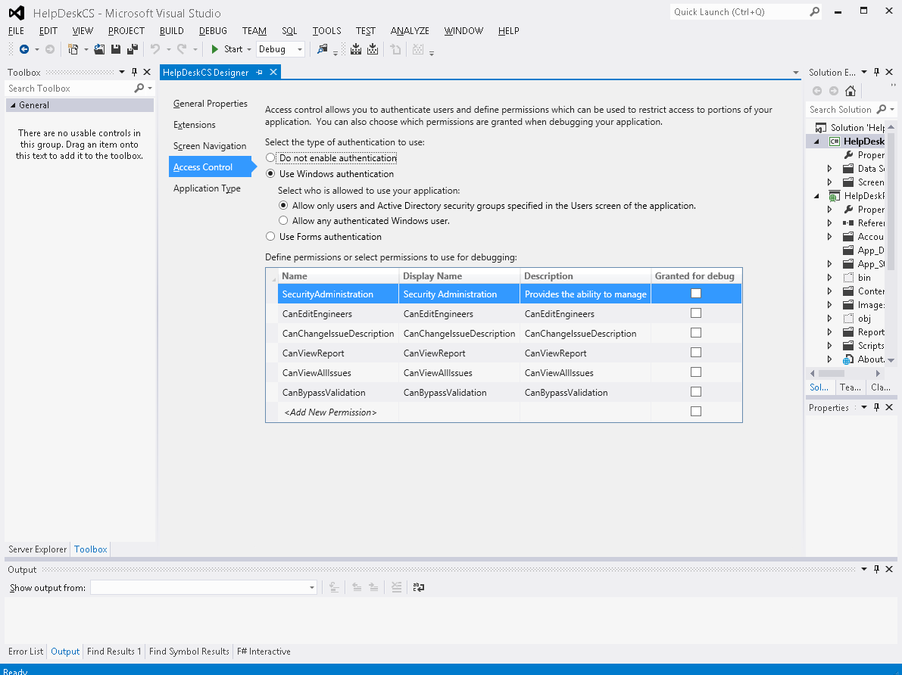

For demonstration purposes, when you log onto this application as a user without the CanViewAllIssues permission, the code assumes that you’re logging in as the first user in the engineer table. The application then filters the issue records in the application so that you only see the records that are assigned to the first engineer in the issue table. In reality, you’d create logins and assign those to engineer records and you’ll find full details of how to do this in the chapter.

## Logging in as an Manager

To mimic logging in as an engineer, check all of the permissions and run the application.

